ชิ้นงานเขียนโปรแกรมอย่างง่าย สอนโดยครูวัชระ วงษ์ดี วิชาการโปรแกรม2 (EIS) ภาค 2/2557 โรงเรียนตากพิทยาคม)
The Practice of easy Programming. ( http://tps.comsci.info, Computer Science for Takphitthayakhom School )
(Send to ftp://tak.comsci.info Username : tak@tak.comsci.info Password : 1234 to pro2-2557 )
Explanation : Writing to English language only in this paper. Unless the word “thai.” (คำชี้แจง : เขียนเป็นภาษาอังกฤษ ยกเว้นระบุ “thai”)
Name……angsumalee thanhirun ……………………. Class. 5/…6……… No.. …41……… ID. ………30029…………………..
Name…… kanchana mangmee……………………. Class. 5/…6……… No.. …48……… ID. ………31533………………..
Name……nipaporn innamrum ……………………. Class. 5/…6……… No.. …51……… ID. ………31537…………………..
Thai Problem(โจทย์ปัญหาภาษาไทย).........................งาน....................................................
English Problem. (โจทย์ปัญหาภาษาอังกฤษ).... work........................................................................................................
0. Definition of Problem (นิยามปัญหา)
0.3 Definition to Design for screen. (นิยามออกแบบจอภาพ)
Label_Problem=…work…………………….
label_d1……..work _done.… …… = label_v121

label_d122………………..……… = label_v122
label_d11… assignment…....… = textbox_v111

label_d112……………….…… = textbox_v112

label_d113…………………..... = textbox_v113

button_calculate1
………………………………………………………..
label_d114…………………..... = textbox_v114

0.2 Definition to Picture or Formulation (รูปภาพหรือสูตรสมการ)
work _done = assignment
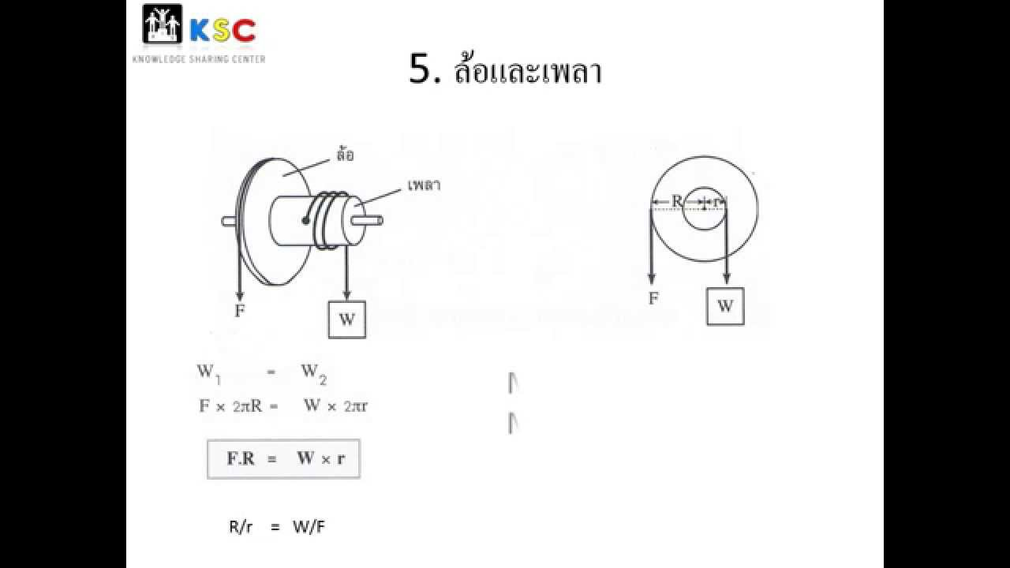
0.1 Definition to Vocabulary (นิยามศัพท์)
d1.1.1 work_done งานที่ได้
d1.1.2 assignment งานที่ให้
d1.1.3
d1.1.4
d1.2.1…
d1.2.2
............................. thai=...............................
............................. thai=...............................
............................. thai=...............................
............................. thai=...............................
............................. thai=...............................
............................. thai=...............................

0.4 Referrent http://. http://www.rmutphysics.com/physics/oldfront.......
1. Problem Analysis (การวิเคราะห์ปัญหา คือนำข้อมูลเข้า-ออกให้เป็นขั้นตอนทั่วไป)
1.1 Input v1.1.1………… assignment …… ………v1.1.2………………………v1.1.3………………………..
v1.1.4………………………v1.1.5…………………………v1.1.6………………………..
1.2 Output v1.2.1…… … work _done ……………………v1.2.2……………………………….
1.3 Process: The Process is analysis about input and output to a common and make a general step. (วิเคราะห์ข้อมูลต่างๆให้เป็นขั้นตอนทั่วไป)
s1.3.1 READ….………… … assignment …………………………………………… s1.3.5 ……………. ……………. ……………. ……
s1.3.2 CALCULATE…… …… work _done = assignment………………………… s1.3.6 ……………. ……………. ……………. ……
s1.3.3 PRINT……… work _done …………………………………………………… s1.3.7 ……………. ……………. ……………. ……
s1.3.4 ……………… ………………………………………… s1.3.8 ……………. ……………. ……………. ……

2. Algorithms is step detailed.-->2.1 The Pseudo code is the process in problem analysis convert to a detailed algorithm.
(2. Algorithms คือ ออกแบบขั้นตอนวิธีอย่างละเอียด→2.1 Pseudo code รหัสเทียม คือนำกระบวนการมาเขียนขั้นตอนให้ละเอียด)
s2.1.1 START……………………………………………………………………… s2.1.11…………………………………………………
s2.1.2 SET…… work _done ,assignment ………………………………… s2.1.12………………………………….………………
s2.1.3 READ ……… assignment …………………………………………………. s2.1.13………………………………….………………
s2.1.4 CALCULATE………… work _done = assignment … ………..s2.1.14………………………………….………………
s2.1.5 PRINT……… work _done ……………… s2.1.15………………………………….………………
s2.1.6 ……………………………………………… s2.1.16………………………………….………………
s2.1.7 ……………………………………………………………………………… s2.1.17………………………………….………………
s2.1.8 ……………………………………………………………………………… s2.1.18………………………………….………………
s2.1.9 ……………………………………………………………………………… s2.1.19………………………………….………………
s2.1.10 ………………………………………………………………………………s2.1.20………………………………….………………

Pages 2

Name……………………..…………………………………………. Class. 5/………… No.. ………… Member Level =……..
2. Algorithms → 2.2 Flowchart (เขียนผังงานโปรแกรม) 3. Coding (ดำเนินการเขียนโปรแกรม)
The Flowchart is convert from Pseudo code to symbols. The Coding is convert from Flowchart to Source code. (V. C#)
Start
{ // Start Program

work _done ,assignment
// SET Variable : <Data type> <Variable name1> , <VN2> , <VNx...> ;
// If Data type is integer such as …-2, -1, 0, 1,2… use “int”
// If Data type is Real Number such as 3.14.., -52.1.., 0.5… use “double”
// Exmple1 : int base1, height2, triangle_area3 ;
// Exmple2 : double base1, height2, triangle_area3 ;

… double work _done ,assignment;
……………………………………………

……………………………………………………………………….

assignment
// READ :
// <Variable name> = Convert.To<int32 or Double>(textbox_v….Text);
//Input Exmple1 : base1 = Convert.ToInt32(textbox_v111.Text);
// Input Exmple2 : base1 = Convert.ToDouble(textbox_v111.Text);

……assignment= Convert.ToDouble(textbox_ assignment.Text);
……………………………………………………………………….

……………………………………………………………………….

work _done = assignment

work _done

// CALCULATE :
//Ex1. triangle_area3 = 0.5 * base1 * height2;
work _done = assignment;

……………………………………………………………………….

End

// PRINT :
label_v……….Text = Convert.ToString ( <Variable name> );
// Ex1. label_v121.Text = Convert.ToString (triangle_area3);
…..label_ work _done.Text = Convert.ToString (work _done);
……………………………………………………………………….

} // End Program

4. Testing. (การทดสอบโปรแกรม) at the back of this paper. (ระบุข้อผิดพลาดต่างๆ )
Assign the error such as …………………………………………………………………………………………………………………………………………….
5. Documentation and Maintenance (การจัดทำเอกสารและบำรุงรักษาโปรแกรม)
5.1 Type all documents to Microsoft word and save to formal file is “c56-no-idxxxxx-name-surname.doc”
Example : c56-no-idxxxxx-watchara-wongdee.doc
5.2 Send to the ftp://tak.comsci.info Username : tak@tak.comsci.info Password : 1234 to pro2-2557/…......
5.3 (View Practice to the http://tps.comsci.info/...................................................................

